**Interface vs abstract class**

A class is made abstract by declaring at least one of its functions as pure virtual function

**interface**

C++ class with only pure virtual methods

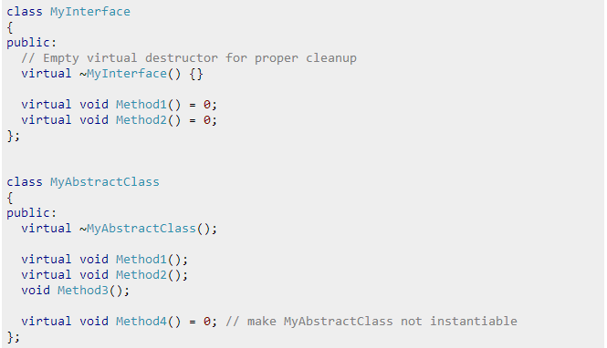**abstract class**

a C++ class with virtual methods that can be overridden

**sources**

**C++ Programming/Classes/Abstract Classes**

http://en.wikibooks.org/wiki/C%2B%2B_Programming/Classes/Abstract_Classes